Clavipectoral fascia
- Fills the space between pectoralis minor and clavicle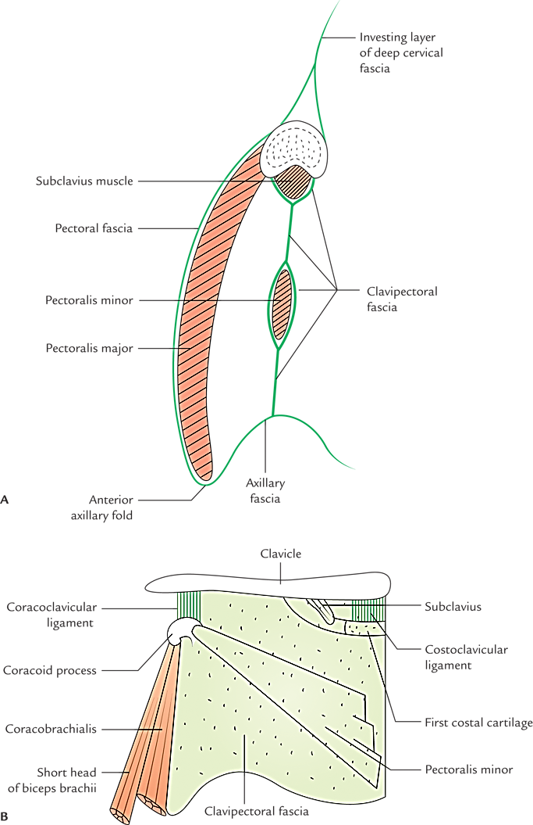

Extent
  - From clavicle to axillary fascia below
  - In the upper part, it slits to enclose the subclavius and adjacent clavicle. Posterior lamina continues as investing layer of deep cervical fascia
  - In the middle it splits and enclose the pectoralis minor muscle
  - In the lower part it blends with axillary fascia
  - In the lower part it is called suspensory ligament of axilla
  - Medially – it blends with external intercostal membrane of upper two intercostal spaces
  - Laterally – it is attached to coracoid process and blends with coracoclavicular ligament
  - Thick upper part of fascia extending from the first rib near costochondral junction to coracoid process is called costoclavicular ligament

Structures piercing clavipectoral fascia
  - Lateral pectoral nerve
  - Thoraco-acromial artery
  - Lymphatics
  - Cephalic vein

